Chapter 4, Problem 73.

Determine the maximum power that can be delivered to the variable resistor R in the circuit of Fig. 4.139.

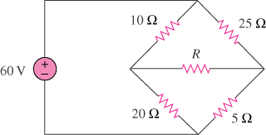

Figure 4.139
For Prob. 4.73.

